Tiny Sequencer

Developed by WA1HCO

Licensed Creative Commons, V4, attribute and share alike

Description
The Tiny Sequencer has four switched outputs for controlling antenna relays, transverters, tranceivers, and other equipment. It has one Key input that activates on 5 to 15 volts and 2 to 3 mA. It has 4 optoisolator outputs that can switch AC or DC up to 28V and 1 Amp. Inputs and outputs are optically isolated from sequencer power and each other. Power to the sequencer is from 6 to 15V or from USB-C. Connections use a 12 position screw terminal block with connections for Power +/-, Key +/-, and four outputs pairs.
Sequencing is controlled by an ATTiny1616 microcontroller. There is also a USB serial port for programming and setting configuration parameters. The USB serial port RTS signal can optionally Key the sequencer. The CTS signal can optionally indicate when the Tx sequence is complete and ready for modulation. There is a transmit timeout option which can return to Rx mode if Keyed for too long.
Each step in the sequence has separate time delays for the Tx and Rx transitions. In addition, each step can operate at OPEN or CLOSED on Rx.

Project files
The project files are saved as two Git Hub projects
- https://github.com/wa1hco/Tiny_Sequencer_Hardware
- https://github.com/wa1hco/Tiny_Sequencer_Software

Status LEDs
  - Green, power
  - Green, software controlled
  - Green, Serial port Tx and Rx data
  - Red, sequencer output closed or each of 4 outputs

Sequencer Output Specifications
  - 4 ports
  - Load Voltage 28V, AC or DC
  - Load Current 1A
  - On Resistance, 68 mOhms
  - Turn on time 1.3 msec
  - Turn off time 0.8 msec
  - Isolation 2500V
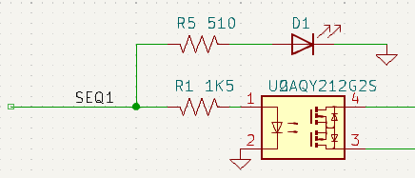Figure 1: Sequencer output circuit

Key Input Specifications
  - Key+ and Key- pins
  - V_{in} off < 1V
  - V_{in} on > 5
  - V_{in} max 15 V
  - R_{in} 2.2K
  - Isolation 3750V
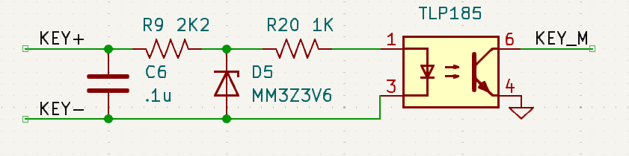Figure 2: Key input circuit

Extra Pins
The six spare GPIO pins on the MCU are brought out to header pins. There is an 8 pin header with VCC, Gnd, PA4, PA5, PA6, PA7, PB5 and PB4. These GPIO pins route directly to the MCU without filtering or projection...becareful. The functions of these pin is undefined except to set the pin mode to OUTPUT, to lower their impedance and provide some protection.

Serial Interface
The sequencer board includes a USB C connector connected to an FT230 serial port adapter. The board has a green LED to indicate serial Tx or Rx activity on the interface. The Tx and Rx lines connect to both the microcontroller serial port pins and to the UPDI programming interface. A jumper is used to select serial comms or programming mode for the serial interface. The RTS and CTS lines connect to GPIO pins on the microcontroller.

Board layout
The front side view shows the component placement, traces, and dimension of board and mounting holes.
The back side assembly view show the pin names as a connection guide. It also show how the ground plan is removed around the optoisolators to minimize capacitive coupling.
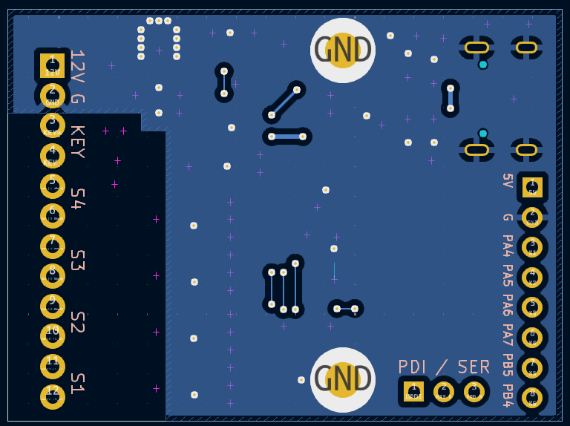Figure 4: Back side silkscreen showing pin names
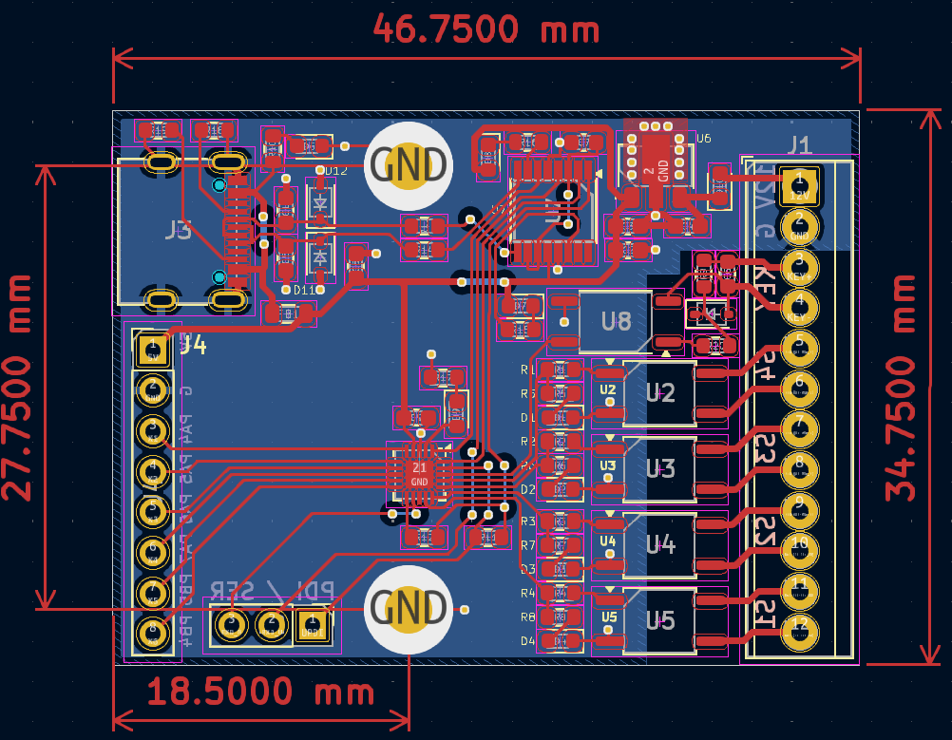Figure 3: Front side view

Software

Sequencer
The software implements a state machine for the sequencer operation. States are
  - Rx state
  - four Tx delay states
  - Tx state
  - four Rx delay states

When a state transition occurs, either by key state change or time delay expired,
  - Associated sequencer output is immediately closed or opened
  - Stay in the state until DELAY elapses to allow time for the external device to response
  - Transition to the next state
Drawing 1: Sequencer State Machine, ASCII Art
// State Machine ASCII art, legend () for state name, [] for event name
//
// |--->( Rx )--->|
// | (test key, RST) |
// | (clr TxTimeout) v
// [unkey] [key]
// ^ |
// |---->\ | /----->[key]----->\ v /<----|
// [delay] (S1R) (S1T) [delay]
// |<----/ ^ \<----[unkey]<----/ | \>----|
// | |
// |---->\ | /----->[key]----->\ v /<----|
// [delay] (S1R) (S1T) [delay]
// |<----/ ^ \<----[unkey]<----/ | \>----|
// | |
// |---->\ | /----->[key]----->\ v /<----|
// [delay] (S1R) (S1T) [delay]
// |<----/ ^ \<----[unkey]<----/ | \>----|
// | |
// |---->\ | /----->[key]----->\ v /<----|
// [delay] (S1R) (S1T) [delay]
// |<----/ ^ \<----[unkey]<----/ | \>----|
// | v
// [unkey] [key]
// \ /
// <--( Tx )<--
Each state watches for the Key signal to change. For example, if the Rx to Tx sequence is ongoing and the Key is released, the current Rx to Tx state immediately transitions to the corresponding Tx to Rx state. This immediately transitions the output to Rx mode and waits the full delay for it to settle. Intermittent input to the Key line still implements the full delays and proper sequencing.
There are separate configurable delays settings for the Rx to Tx transition and the Tx to Rx transition.
The polarity of the Key line is always to Key on voltage on the optoisolator, the user can wire the two floating pins of the Key input to either volta to key or ground to key.
The polarity of the RTS and CTS lines are always UP for Tx and DOWN for Rx.
The polarity or “form” of the outputs is configurable to OPEN on Rx or CLOSED on RX. However when not powered the sequencer outputs are OPEN.
The sequencer state machine is executed on 10 msec intervals from a timer interrupt. This has the effect of add some delay to processing. Tx and Rx delays are about 10 to 15 msec greater than configuration parameter calls for.

Configurable Parameters
The sequencer has a range of configuration parameters stored in non volatile EEPROM on the MCU.
  - Sequencer step contacts OPEN or CLOSED on RX
  - Sequencer step Tx delay, 0 to 255 msec
  - Sequencer step Rx delay, 0 to 255 msec
  - RTS enabled or disabled,
  - CTS enabled or disabled, DOWN is disabled
  - Tx Timeout, 0 to 255 seconds, 0 seconds means timeout disabled

On startup, the program reads the EEPROM and checks the “checksum” (CRC16). If not valid, the configuration reverts to pre-programmed defaults.

Configuration Interface
A command line user interface is available through the USB serial port. The user enters a line of characters containing commands, command arguments and numbers. These commands then write configuration to the EEPROM. The commands available to the user are…
  - Step {step number}{Tx delay, Rx delay, Open on Rx, Closed on Rx}
  - RTS {Enabled, Disabled}
  - CTS {Enabled, Disabled}
  - Timeout { 0 to 255 msec, 0 means disabled}
  - INIT, initialize to programmed configuration
  - RESET, restart the software as if from power up
  - Help, print information about the user interface

The command line is broken down into tokens separated by blanks. Tokens may be letters or numbers. For the Step, RTS, CTS and Timeout commands, only the first letter is required. But the Init and Boot commands require the whole token to match which reduces the risk of error. The arguments to the commands also work with only the first letter. Letter commands can use upper or lower case.
The step number argument is checked to fall with the range 0 to 3, corresponding to steps 1 through 3. The delay and timeout arguments must fall with the range 0 to 255.
Due to limitations in the Arduino serial interface, echo is at the line level. Individual characters are not echoed by the USB Serial interface.

Configuration Examples
  - Command Description
  - Step 0 Rx 100 Step 0 Rx delay is set to 100 msec
  - s 0 r 100 Same command, first letter only, case doesn’t matter
  - S 0 R 100 Same command, case doesn’t matter
  - s 1 o Step 1 Open on Rx
  - s 3 c Step 3 Closed on Rx
  - r e RTS enable)
  - c e CTS enable
  - t 120 Timeout 120 seconds
  - Boot restart as if power up, case sensitive
  - Init Initialize EEPROM to preprogrammed defaults, case sensitive

